
GREAT HASELEY
HOUSING NEEDS SURVEY
September 2015

Dear Resident

As we know, the cost of a home in the parish of Great Haseley is very high. In the OX44 postcode area, which includes Great Haseley, a terraced house cost a median of just over £350,000 in May 2015 (source: www.home.co.uk).

This is over 13 times median gross earnings in South Oxfordshire district (£25,974, source: Annual Survey of Hours and Earnings 2014). Many people simply can’t afford that amount. Great Haseley Parish Council has been in discussion with Soha Housing Association regarding the building of a small number of affordable homes on a site at Rectory Road. This survey invites residents to express an interest in one of these affordable homes.

Affordable housing is, in essence, for those who cannot afford to rent or buy on the open market, or who would have significant financial difficulties in doing so.

Those in housing need can include:

· People seeking their first independent home
· Older people who may be thinking of moving to smaller, more manageable housing
· People living in overcrowded or unsatisfactory housing
· People struggling to afford their current home

It is very important that this survey is confidential. Therefore, it is being organised with the assistance of Oxfordshire Rural Community Council (ORCC). ORCC is a community development charity that works with and supports communities across Oxfordshire and has long-standing expertise in helping communities with consultation strategies. All information given will be KEPT CONFIDENTIAL BY ORCC (unless indicated otherwise on p.6) in accordance with the data protection principles set out in the Data Protection Act (1998). ORCC will analyse the survey results and prepare a summary report for the Parish Council.

In small villages, affordable housing is usually built on a Rural Exception Site. All affordable homes on a Rural Exception Site are:

· owned by a Housing Association (no homes can be sold privately)
· rented or part-sold (shared-ownership) and cannot be sold outright
· will be allocated to those with genuine local connections (see pages 3-4 for more detail)

On RES, Local Authorities can grant permission for some open-market homes to assist in the provision of
affordable housing to meet local needs if they consider that is appropriate to help subsidise the costs of
building any new homes.

We would like to have the views of everyone on this important issue. All households are asked to complete Part 1. Part 2 is for those interested in renting or part-buying an affordable home within the next few years. If you know of anyone not currently living in the parish but who might be interested in returning to live here, please ensure they are given a survey.

Assistance with completing the form and additional surveys is available from Tom McCulloch (01865 883488, tom.mcculloch@oxonrcc.org.uk)

PLEASE RETURN YOUR COMPLETED FORM IN THE ENCLOSED FREEPOST ENVELOPE BY 23 SEPTEMBER

Great Haseley Parish Council
Your Home

1. How many people of each age live in your home? (write number in box) |  | 0-10  years | 11-20 years | 21-44 years | 45-64 years | 65-74 years | 75-84 years | 85+  years
 | Male
 | Female

2. What type of house do you live in? (please tick) | House |  | Flat |  | Other (specify below)
2. What type of house do you live in? (please tick) | Bungalow |  | Caravan/ Mobile Home
3. How many bedrooms does your home have? | 1 2 3 4 5+
4. Who owns your home? | Self (with/ without mortgage) |  | Parents/ relatives |  | Tied to job
4. Who owns your home? | Private landlord |  | Housing Association |  | Other

Your Household
5. Have any members of your household left the parish in the last 5 years? | Yes (write total No  number of leavers in box)
 | 1st leaver | 2nd  leaver | 3rd  leaver | 4th  leaver | 5th  leaver
6. How long ago did they leave? (years)
7. Why did they leave? (please tick all that apply):

Employment
Further education
Lack of affordable housing
Other (please give details):

8. Would they return if there was affordable housing in the parish of Great Haseley? (write yes, no, maybe in box)

9. Does anyone living in your home need a home now or in the next 5 years? | No Yes (put total number in box)

You and Your Parish

10. How long have you lived in the parish of Great Haseley? (write number of years in box) | This home This parish
11. Would you support a small development that provides affordable housing to individuals or families with genuine local connections to the parish of Great Haseley? | No Yes Maybe

Local Homes for Local People-
Affordable Housing on Rural Exception Sites
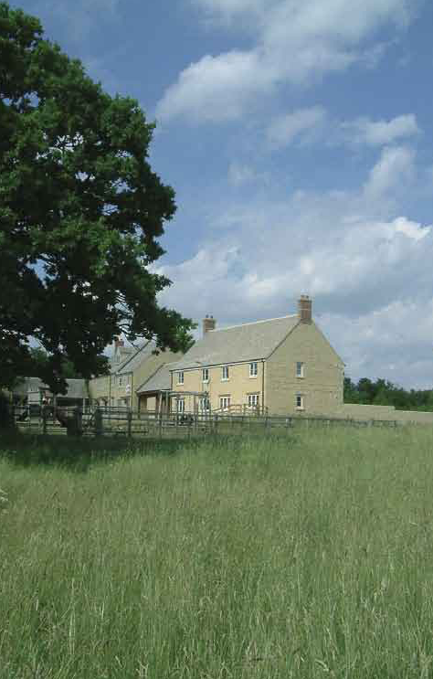
Local Connections Criteria:

These are set out in each District Council’s Allocations Policy and will be checked by the District Housing Needs Team.

- The householder must currently be resident in the parish* (and/ or)

- Previously resident in the parish* (and/ or)

- Have family connections to the parish* (and/ or)

- Work in the parish*

*the exact definition of length of residence, family connections etc. are contained in the District Allocations Policy.

What are Rural Exception Site Homes?
- RES homes help meet a demonstrated local affordable housing need

- On RES, the District Council can grant permission for some open-market homes to assist in the provision of affordable housing to meet local needs (if they consider that is appropriate)

- RES homes fulfil all other planning requirements

- RES homes are owned by a Housing
Association and cannot be sold
privately

- RES homes are rented or part-sold
(shared ownership)

- RES homes give first priority to those with local parish connections. Second priority is given to those living in agreed surrounding parishes (as stated in the nominations agreement for each scheme).

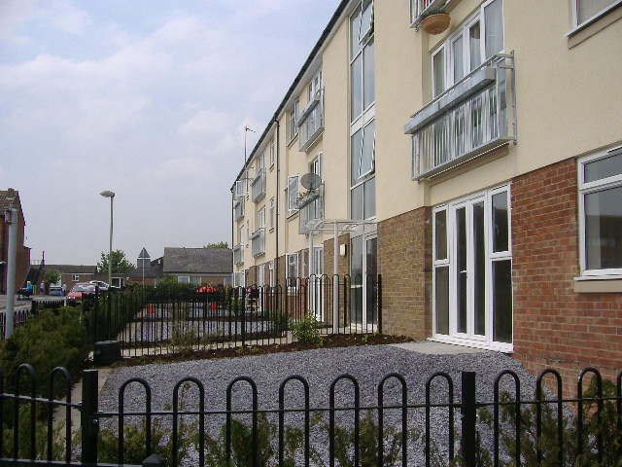

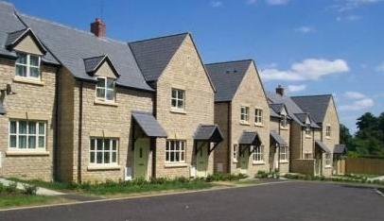

Clockwise from top right, Rural Exception Site developments in Charlbury, Steeple Aston and Berinsfield

Local Homes for Local People-
Affordable Housing on Rural Exception Sites

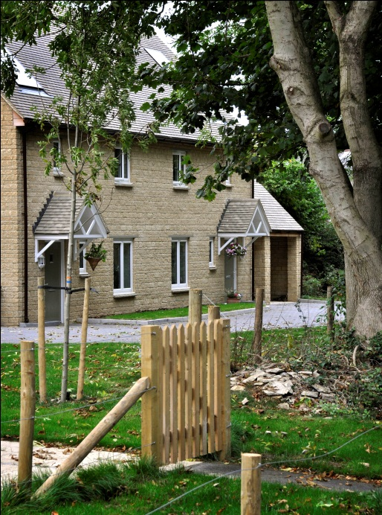
Eco-Friendly Features in RES Homes*

- More energy-efficient, meaning
lower energy bills

- Designed to use no more than
about 105 litres of water per
person per day

- Energy efficient lighting

- Photovoltaic panels

- High efficiency condensing boiler

- Biomass heating

- Ground source heat pumps

* features vary from site to site

Local Homes for Local
People- Pam in Tackley

‘‘It was great growing up here. It felt a very safe place. But I realised that my husband and I wouldn't be able to afford anything for at least for a couple of years.

The Rural Exception Site Development allowed us to stay. It’s worked really well and enabled so many other villagers to stay and that’s brilliant!’’
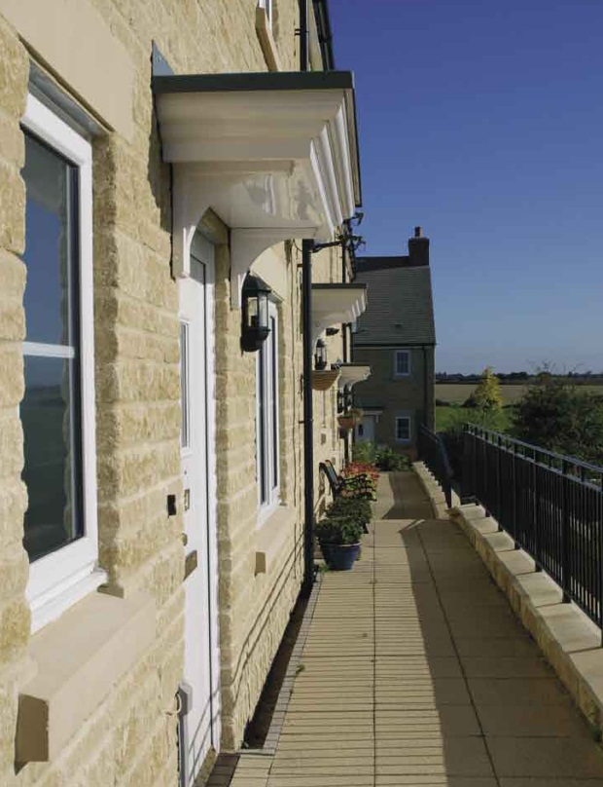

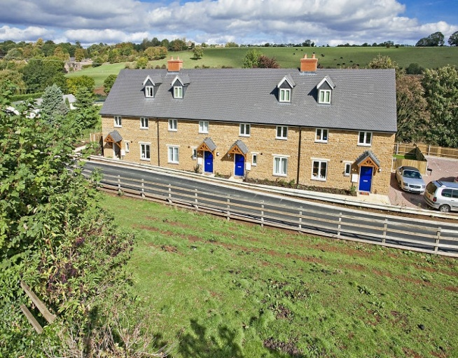

Clockwise from top left, Rural
Exception Site developments in Ramsden, Stonesfield and Hornton

Your Affordable Housing Needs

12. How many people of each  age group would live in the  new home? (include carers  if support needed to live independently) |  | 0-10  years | 11-20 years | 21-44 years | 45-64 years | 65-74 years | 75-84 years | 85+  years
 | Male
 | Female

13. Why do you need a new home in this parish? (please tick all that apply) | Want to start first home |  | Tenure insecure |  | Divorce/ separation |  | Retiring
 | Need bigger home |  | Need smaller home |  | To be near family |  | Other (specify below)
 | Special needs |  | Job insecurity |  | To be near work
14. Who owns the home you live in now? | Self (with/ without mortgage) |  | Parents/ relatives |  | Tied to job
14. Who owns the home you live in now? | Private rented |  | Housing Association |  | Other
15. Is there anything that might affect the type of home you need? | No |  | Yes, limited mobility |  | Yes, wheelchair used |  | Yes, other (please specify)
16. What type of home would best meet your needs? | House |  | Flat |  | Bungalow |  | Ground floor accommodation
17. Does anyone in your home have a supported housing need? | No Yes, support needed Yes, other  to live independently (please specify)
18. Which of the following would be best for you? | Rent from Housing Shared Ownership Either  Association (HA) (part rent/ part buy with HA)
19. How many bedrooms will your new home need?* | - 2 3 4 5+

* There are restrictions on the number of bedrooms you would be considered eligible for, depending on the make-up of your household and whether your home is rented or purchased on a shared ownership basis.

20. Can you give us some idea of how much rent/ mortgage you could afford to pay per month?

21. If you are interested in shared-ownership, how much do you think you would be able to put down as a deposit? Include all available funding sources, e.g. parents, family, savings
22. Can you give us some idea of your household’s monthly income after tax (including benefits, except housing benefit)?

PLEASE TURN OVER
23. Do you live in the parish of Great Haseley at the moment? | No Yes How many years?
24. If you do not live in the parish of Great Haseley just now, what is your connection to it (please tick all that apply)? | Used to live in the parish |  | How many years?
 | Family lives in the parish |  | How many years?
 | Work in the parish full-time |  | How many years?
 | Work in the parish part-time |  | How many years?
 | Voluntary work in the parish |  | How many years?

To be considered for an affordable home, in Great Haseley or elsewhere in the District, you must be registered on the South Oxfordshire District Council Housing Register. It is in your interest to register as soon as possible. Forms are available from SODC and online at:
http://www.southoxon.gov.uk/services-and-advice/housing/join-housing-register-and-find-home

25. Are you on the South Oxfordshire District Council Housing Register? | Yes No
Please indicate whether you agree to the information you have provided in this form being shared with South Oxfordshire DC Housing Department. | Yes, I agree No, I do  not agree

Please use the space below (continue on back page) if you wish to make comments. You should be aware that these comments may be included- anonymously- in the final report which is made to the Parish Council.

If this survey shows that there is a need for affordable housing for local people, we may have to get back in touch with those people who have said they are in need, as we work with the Local Authority and Housing Associations to deliver the homes. IT WOULD BE HELPFUL TO US AND YOU IF YOU INCLUDE YOUR CONTACT DETAILS BELOW.
Name: Phone Number:
Address:

THANK YOU FOR TAKING THE TIME TO COMPLETE THIS QUESTIONNAIRE. PLEASE RETURN, USING THE FREEPOST ENVELOPE, BY 23 SEPTEMBER.

